NOTES ON ASTRONOMICAL OPTICS

Introduction

What follows is a definition of the tentative scope of the subject.
Astronomy is the science dealing with all outside the terrestrial atmosphere.
If one has the good luck to find a just fallen meteor, it can do good astronomy with a pick and shovel.
Some of the best astronomy has been done with complex neutrino detectors.
But the vast majority of astronomical information come as electromagnetic waves, and to extract it is necesary to know the nature of these waves
Next, this knowledge may be applied to the invention, design, construction and use of some astronomical instruments, and to reduction of data given by them.
Historically, most information came from the visible spectrum, and the smallness of the visible wavelength originated the so called geometrical optics, wholly based on the concept of light rays.
The electromagnetic nature of ''light'' is seen in radiotelescopes, interferometers, polarimeters, diffraction gratings, interference filters, and the detailed analysis of images predicted by geometrical optics.
According to this scheme, the material presented here lack some things, but none is superfluous.
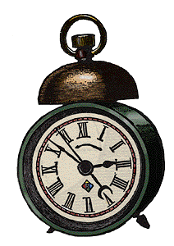
The first section is taken as known from other courses, but it is included here as a quick reference to later topics.

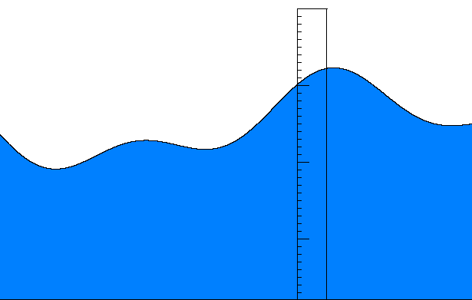
1. Waves

What is a wave? The simplest example is a sea wave, before breaking. A graph of the water height as a function of time, taken at a fixed pole, is identical to a photograph of the water shape, (Fig 1.1). The graph at the pole is obtained by taking constant 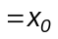
The photograph is obtained at a time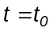. The shape moves as a block at a velocity c, that can be positive or negative.
All this may be summarized in the equation
Fig. 1.1
(1.1) 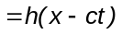

Where is the height, the coordinate and t the time.
For a time 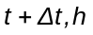 has the same value at certain 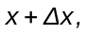 such that 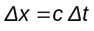

Differential equation of waves

Eq (1.1) is solution of the differential equation.

(1. 2) 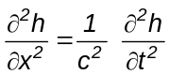
This equation is called the wave equation.

Exercise

Verify it, taking an auxiliar variable 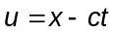 and operating on the derivatives

Electric and magnetic units
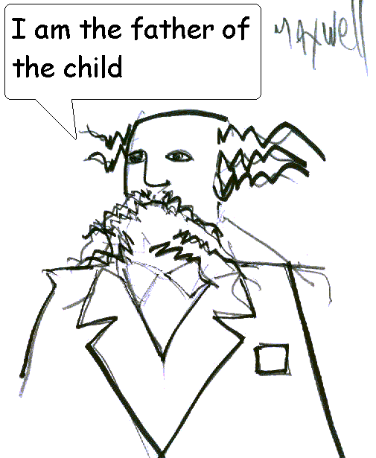
Brief description of electric and magnetic fields and unit systems.
The MKS system of units must be completed with a new one to include electromagnetic phenomena.
The physical entities are defined from the following experimental laws.

Lorenz law
(1.3) 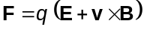
Where

F = force q = electric charge E = electric field
v = velocity of q B = magnetic field.

This equation introduces q, B, E

Coulomb law

(1.4) 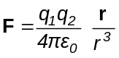
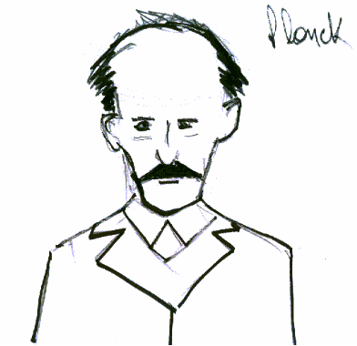
Where
F = force 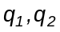 =
charges r = distance from 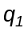 to  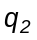

It may also be written as F =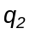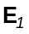; with =
electric field produced by 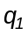.
This equation is analogous to the law of
gravitation, and introduces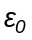= dimensional constant.

Ampere law
(1.5) 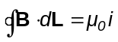 
B = magnetic field dL = element of length
i = electric current linked by the circuit of integration.

Definition of electric current: flow of charge = dq / dt 
This equation introduces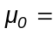dimensional constant.
Newton's law, F = mass x acceleration, connects with the mechanical system MKS.
The MKSQ system has as fundamental units:

Length: meter = m
Mass: kilogram = k They are defined by experiments.
Time: second = s
Charge: coulomb = q

Let's see the units of E, B, q,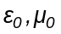

The unit of force is the newton, 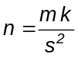
Using (1.3), if v = 0 results in n = q E ; then
(1.6) 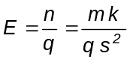 This is called "volt / m"

And if E = 0 results in 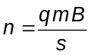 ; then

(1.7) 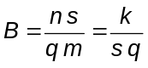 This is called "Tesla"

Using (1.4) is 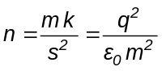 ; then

(1.8) 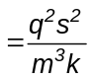

Using (1.5) is 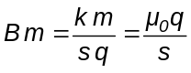 ; then

(1.9) 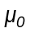= 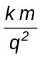

Units of the product 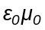

(1.10) = 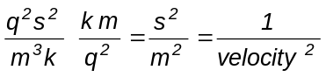

Maxwell equations

Maxwell equations in vacuum link E and B without intervention of charges.

(1.11) 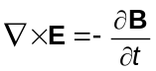

(1.12) 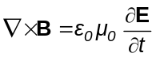   

(1.13) 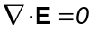

(1.14) 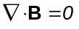

Equation of electromagnetic waves

Taking × in (1.11)

(1.15) 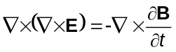
Taking 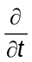 in (1.12)

(1.16) 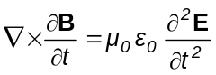
              

Using the vectorial identity
(1.17) 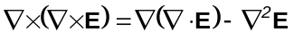

The first member of the second term is zero by (1.13)
Results
(1.18) 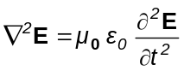
This is is a three dimensional wave equation, with c = 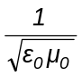
It may be shown that the same equation is obtained for B.
With electromagnetic waves, the magnitude producing observable effects is generally E. The field B sustains the propagation.

To think
Electromagnetic waves, luckily for astronomers, needs no material medium to propagate. This property makes them very special and hide facts that its author never had imagined.

Types of waves

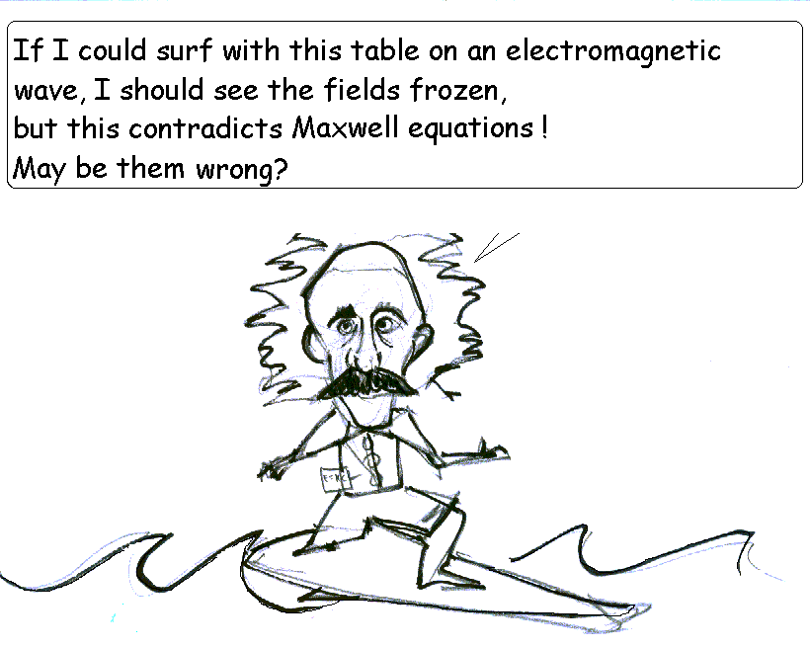
Harmonic waves. They has the expression

(1.19) 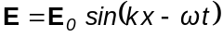, or also
(1.20) 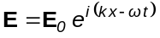 ( real part ) The last expression is more manageable mathematically. Here, k = wave number.
= angular frequency or pulsation. 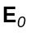is a complex amplitude and may be written in detail as 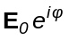. This form will be most used in the discussions.

Alternative notation
(1.21) 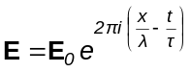

Here, = wavelength, = period.

Harmonic plane waves in three dimensions

The former say that E is constant in planes normal to the x axis, and the waves travel along x. If they travel in any direction, results (for example)

(1.22) 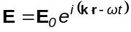 r = x, y, z y k = 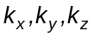

E is constant in the planes 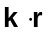= cte, advancing in direction of the wave vector k with velocity
(1.23) 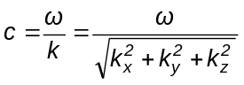

Spherical harmonic waves. They has the expression

(1.24) 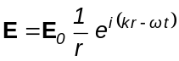

They are three dimensional waves, and the factor 1/r is required. No spherical waves (harmonic or not), can exist with an equation of the type E = E( r - c t ).
A reason for the factor 1/r will be shown later.

Relations among E, B, y k for a plane harmonic wave

Let 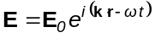
Then
(1.25) 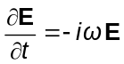 ; 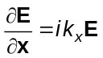 ídem for y, z

As operators
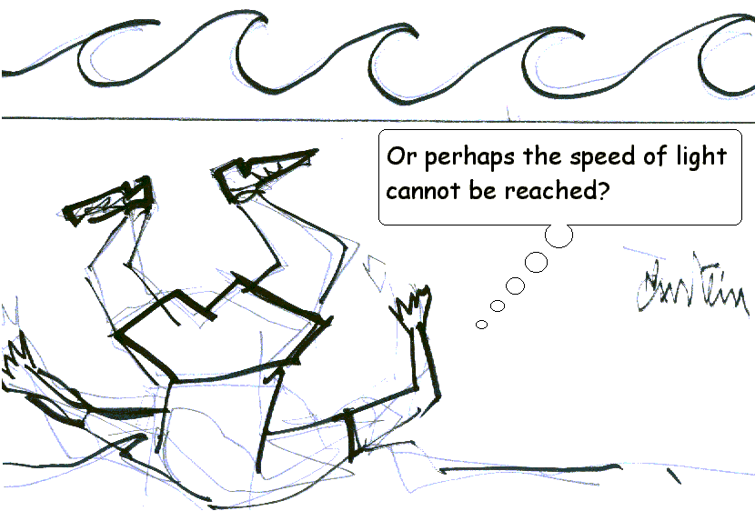
(1.26) 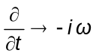 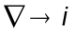k

Maxwell equations in this case take the form
(1.27) k × E =B

(1.28) k × B =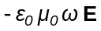

(1.29) k . E = 0

(1.30) k . B = 0

This implies that E, B, k form an orthogonal thriedron. That is, the wave is transverse.

Radiation pressure

If an electromagnetic wave incides on an electron – as those that compound any piece of matter --, the E field moves it in a transverse direction.
By Lorenz law, the associated field B produces a force in direction of k. This force has always the same direction, unlike the electrical one that put it into oscillation, so in this case the observable effect is due to B. Among other things, it produces the comet tails and and keep the stars away from collapse.

Energy flow

The vector
(1.31) 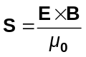
points in direction k and has units
(1.32) 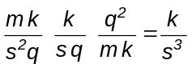

The flow density has the same units

(1.33) 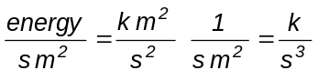

This means that, unless a numerical factor, the energy density carried by an electromagnetic wave is given by S. Even though this is not a proof, a complete analysis yields the same result, that is, the numerical factor is 1.
S is called Poynting vector and also, by definition, is the intensity of the beam.
According to (1.23) and (1.27) is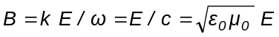
Hence the intensity is proportional to 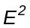

(1.34) I = 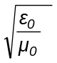

Spherical waves has intensity varying with 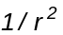, in this way energy is conserved because the total flow through any sphere is constant. This is the "reason" for 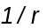 in spherical waves. The true reason is mathematical, but physics thanks it.

Polarization
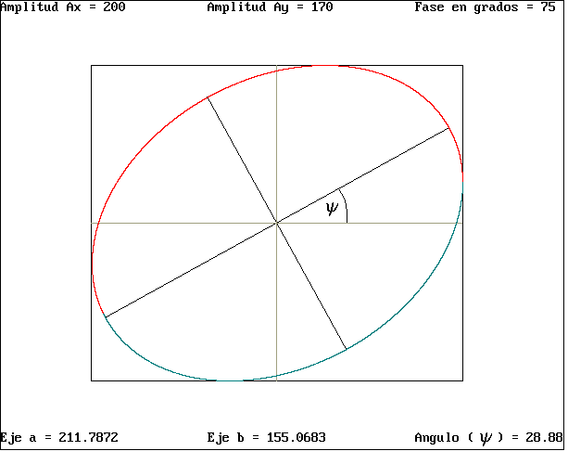
   Solving for the components of E of a plane monochromatic wave in a cartesian system with k on the z axis,
(1.35) 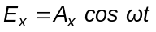
(1.36) 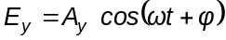

It is easy to verify that if 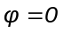, the E vector draws a straight line, an if 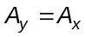 and = + 90 deg.   it draws a circle in one or other direction.
In the general case it draws an ellipse with semiaxes a and b, Fig. 1.2
The ellipse has its major axis tilted an anglefrom the x axis. It is assumed that always is 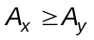.
Fig. 1.2
Other cases can be reduced to this one.
Determination of 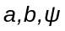 is a complex exercise of analytical geometry and will be stated without proof.
Input: 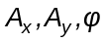 Output:
Taking
(1.37) 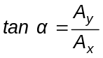 , is

(1.38) 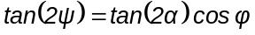

The principal semiaxes a y b obeys

1.39) 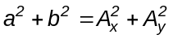
Taking
(1.40) 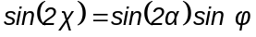 , there results
(1.41) 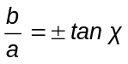
Exercise

Write down a program to generate these figures. Here is one.

Listing ELLIPOLA Compiled ELLIPOLA

It may be a matter of discussion the pros and cons of writing a program instead of deriving the formulas. The best would be to make both things. Here there are intended simple and improvised programs because they are the natural evolution of the simple act of using a slide rule, then a pocket calculator, and later a computer. The examples where done with BASIC QB45 , which allows easy graphic programming.

Stokes parameters

Astronomical observations dealing with polarized light generally refer to the so called Stokes parameters. They will be defined here for reference.

Parameters Relations

(1.42) 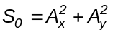 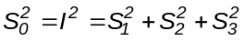
. 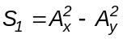 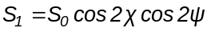
. 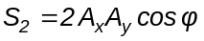 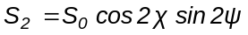
. 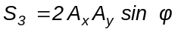 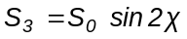

Dielectric refraction and reflection.

Refractive index.
In a dielectric, Maxwell equations remain valid if is replaced by and by .
anddepends on the material. But in dielectrics it also happens that they are very weakly magnetic, so that it may be set approximately 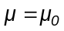. The velocity of propagation in the medium is
(1.43) 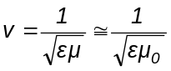. 

The quotient
(1.44) 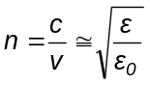
is the refractive index.

Relation between B and E.

The relation similar to (1.28)

(1.45) 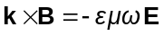 , may be put as
(1.46) 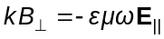.
The lower indices(perpendicular) and ll (paralell), may refer to the plane of the paper, or more generally to the plane containing k and the normal, called incidence plane.
That is
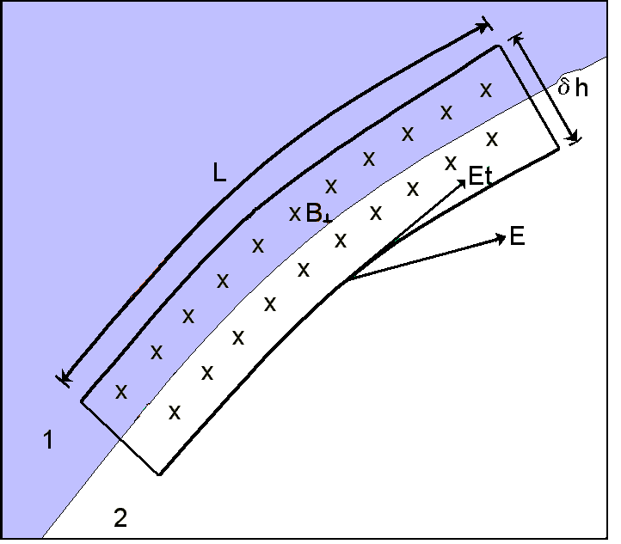
(1.47) 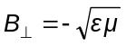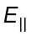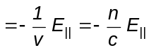

If a wave has 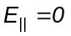, it is called tranverse electric (TE), and if 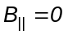, transverse magnetic (TM). Any wave may be expressed as a linear combination of both.

Boundary conditions.

In Fig. 1.3 there is shown a boundary between two dielectrics and a path of integration having a part paralell to the boundary of length L , then a part normal to it of length 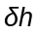 and other two similar closing the circuit. Applying Stokes theorem to the first Maxwell equation results
Fig 1.3
(1.48) 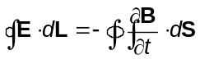

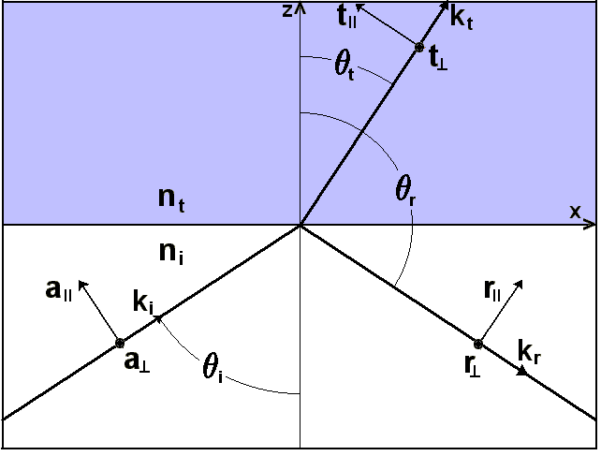
The first integral refer to the circuit and the second to the surface limited by it.

Taking 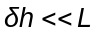and then 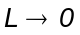, results
(1.49) 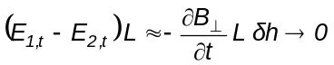.
Here the lower index t means tangential, that is, paralell to L, and indicates normal to the plane of the circuit.
The expression vanishes because the second member is an infinitesimal of larger order than the first.
The conclusion is 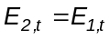, i.e., the tangential component of E is continuous through the boundary.
The same happens with the tangential component of B, by the other equation.
Fig 1.4
The existence of reflected (r), and
transmitted (t) waves, and their amplitudes follow from the fulfillment of these boundary conditions.
The directions of the waves follows from the fact that at the boundary, the three waves are the same.
In Fig 1.4 a plane wave, with its electric field of complex amplitude a and propagation vector 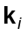contained in the plane x,z, incides on the boundary of two dielectrics lying in the plane x,y. The angles are measured from the z axis.

Directions

At the boundary, the arguments of the three waves i, r, t are identical.

(1.50) 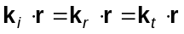

But also, for the three waves is true that

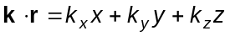
(1.51) 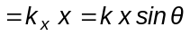

Because at the boundary is z = 0, and 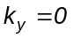 by definition.
The equalities are true for all x
Then
(1.52) 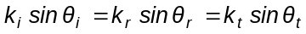

As the velocity in the medium is 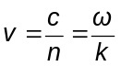, es 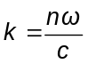.
  Then
(1.53) 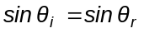 (Law of reflection)

(1.54) 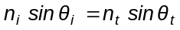 (Snell law)

In the law of reflection, note that the component z of the reflected vector is negative.

(1.55) 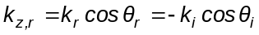

Then
(1.56) 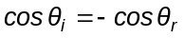

Fresnel formulae for amplitudes

The components of the field E in the incident wave are

(1.57) 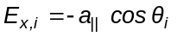 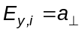

The corresponding of the field B are, by (1.47)

(1.58) 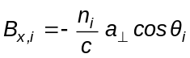 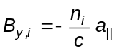
           I a similar way, with the transmitted and reflected waves

(1.59) 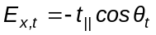 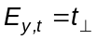

(1.60) 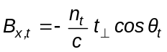 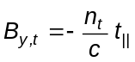

(1.61) 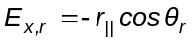 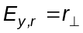

(1.62) 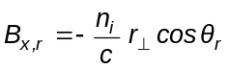 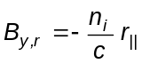

The continuity of the tangential fields is satisfied if

(1.63) 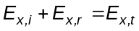

(1.64) 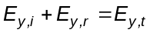

(1.65) 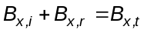

(1.66) 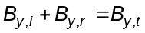

Recalling that 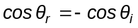, the former yields, respectively

(1.67) 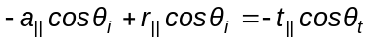
That is
(1.68) 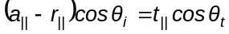

(1.69) 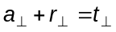

(1.70)

That is
(1.71) 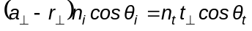

(1.72) 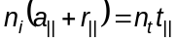

Eqs (1.68) y (1.72) form a system of two equations with two unknowns whose solutions are 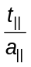y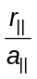, and eqs (1.69) and (1.71) gives 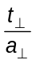and 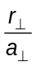

In order to simplify the notation we set 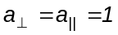, as they are arbitrary.
Hence the solutions are the Fresnel formulae

(1.73) 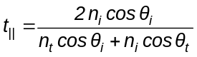

(1.74) 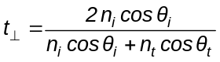

(1.75) 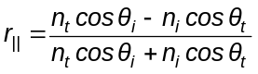

(1.76) 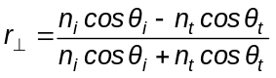

Using Snell law it may be verified the following alternative expression where the refactive indices has been eliminated

(1.77) 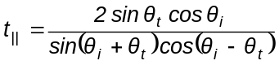

(1.78) 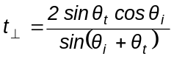

(1.79) 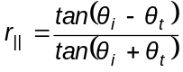

(1.80) 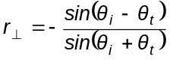    

Transmissivity T and reflectivity R

The intensity, or energy flow density, is referred to an area normal to the propagation, and is
(1.81) 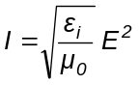

The density through the boundary is affected by an inclination factor and is

(1.82) 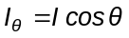

The transmitted and reflected intensities are
(1.83)
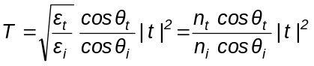

(1.84) 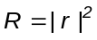

The expression forsimplifies because light is travelling in the same medium
These formulas are valid for each component, ll y

Singular angles

Critical angle. When 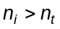, there is an interval of angles between
(1.85) 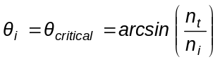

and 90°, for wich the boundary behaves like a mirror. This is said as total reflection.
Brewster or polarizing angle. In the alternative expression (1.79) of , it is evident that if 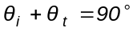 is 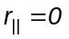, and light is reflected completely polarized. The reflected beam is perpendicular to the transmitted one, and then Snell law yields
(1.86) 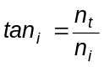
Normal incidence. In this case the formulas are so simplified that is worth to remember them.
The plane of incidence is not defined so there is no polarization.
Results
(1.87) 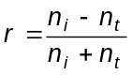

(1.88) 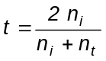
The expression for has a negative sign by the way in wich there are defined the vectors in Fig.1.4
Fig 1.5 show 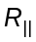 y 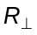as a function of . Red pertains to .

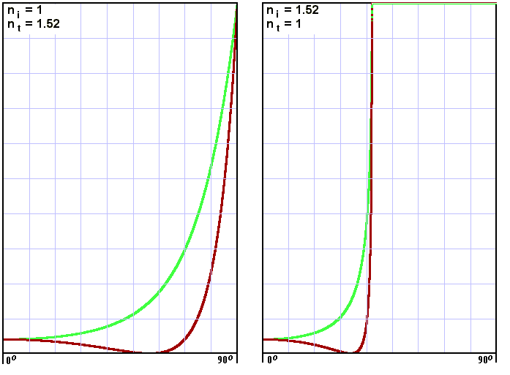
Fig. 1. 5

The critical angle is 41.1 degrees and Brewster's is 56.6 ó 33.3 degrees, depending on the case. At normal incidence both components coincide, and the reflectivity is R = 0.042

Exercise

Write down a program to generate these figures. Here is one.
Listed FRESNELF Compiled FRESNELF

What is the value of in Fig 1.4?

Dissipative media

A non dielectric medium (metals, for example), may be characterized by a complex refractive index, 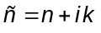. Not to be confused this 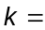index of absorption, with the well known modulus of the wave vector . The name is imposed by the literature.
¿What is the effect of oñ the wave?. Let be the plane wave

(1.89) 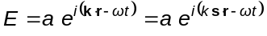

Where is a unit vector in the direction of propagation,and 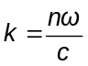
If now is taken , results

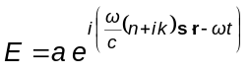

(1.90) 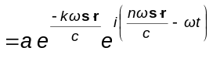

It is a wave damped in direction . The energy is transformed into heat by ohmic dissipation.
Fresnel formulae says that the phase jump is or if the media are dielectric, but it may be any number if any index is complex.
If there is a complex index, it only makes sense the value of with real, because the media are infinite and the waves vanish in other case.
An example is the reflectivity of metals, and it is verified an angle similar to Brewster's in wich 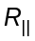 goes through a non-zero minimum.

